Q-1. Write an SQL query to print the FIRST_NAME from Worker table after replacing ‘a’ with ‘A’.
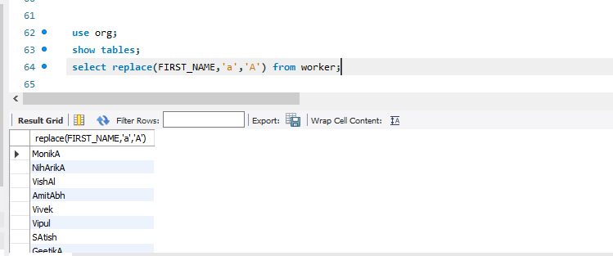
Q-2. Write an SQL query to print all Worker details from the Worker table order by FIRST_NAME Ascending and DEPARTMENT Descending.
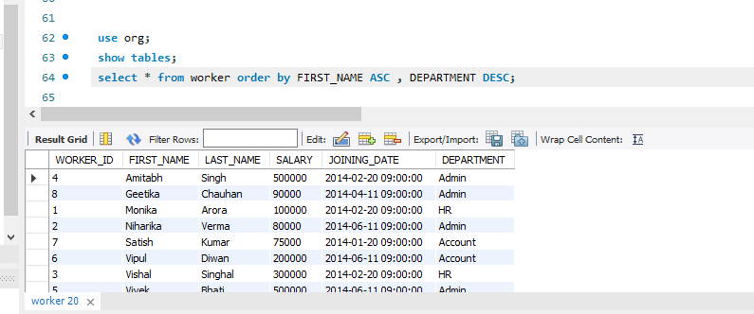
Q-3. Write an SQL query to fetch the names of workers who earn the highest salary.
